**A Research on the Use of Short Videos in College Students**

**Chapter 3 Data Analysis**

**3.1 Reliability analysis**

The reliability of the scale was analyzed and the Cronbach 's α coefficient was used to evaluate the scale.The low reliability : α< 0.35, medium reliability : 0.35 <α< 0.70, high reliability : 0.70 <α. Generally, the α coefficient of the questionnaire is above 0.8, which is of use value. Cronbach 's α values were above 0.85, indicating that the reliability of the questionnaire was good.

According to Table 3.1.1 and Table 3.1.2, the Cronbach 's α coefficient of the questionnaire is 0.902, indicating that the whole questionnaire has high reliability. After deleting a single analysis item, the Cronbach 's α coefficient was above 0.862, indicating that each analysis item had a certain contribution to the overall reliability of the questionnaire, so it was recommended to retain all analysis items. At the same time, the correlation between each analysis item and the overall after deletion is above 0.698, indicating that each analysis item has a certain correlation with the overall, and also supports the retention of all analysis items. In summary, the reliability of the questionnaire is high, and all analysis items can be retained.

|  |  |  |
| --- | --- | --- |
| Cronbach's α coefficient | Items | samples |
| 0.902 | 5 | 29 |

**Table 3.1.1**

|  |  |  |  |  |
| --- | --- | --- | --- | --- |
| index | Item name | Correlation between deleted items and the total after deleting items | Cronbach 's α coefficient after item deletion | conclusion |
| 1 | 一天中观看短视频时间 | 0.805 | 0.869 | good |
| 2 | 经常在社交媒体上分享短视频 | 0.736 | 0.884 | good |
| 3 | 短视频对自己的影响 | 0.834 | 0.862 | good |
| 4 | 短视频可以帮助了解文化和趋势 | 0.698 | 0.892 | good |
| 5 | 短视频可以缓解压力和疲劳 | 0.709 | 0.891 | good |

**Table 3.1.2**

**3.2 Preliminary analysis of survey results**

The survey received a total of 29 questionnaires, 29 valid questionnaires, of which girls accounted for 51.72 %, boys accounted for 48.28 %. In terms of age, respondents were mainly 21-23 years old, accounting for 41.38 %, and 18-20 years old, accounting for 37.93 %. From the selected five colleges, each college accounts for an equal proportion.

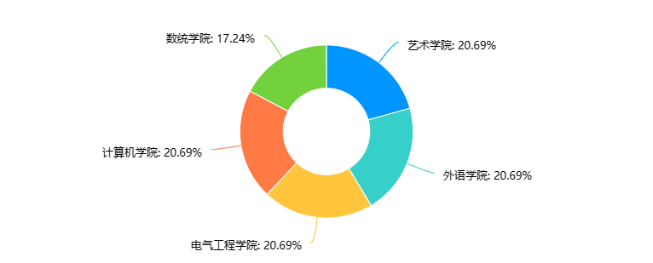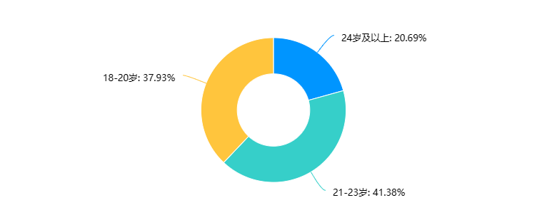

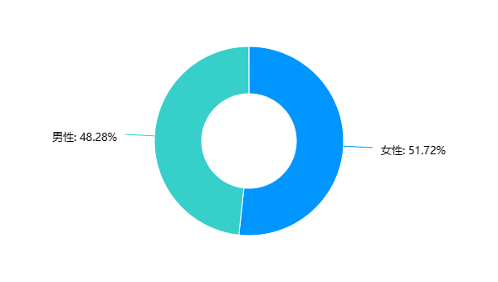

**Figure 3.2.1**

In-depth interviews a total of three college students were interviewed to talk about their views on the short video.

Detailed interview data are located in Appendix 1.

**3.2.1 Analysis of the usage of short video platform**

In general, short video platforms are very popular among college students, who often watch and share videos on the platform. The video needs of college students are more diversified, not only limited to entertainment and recreation, but also to acquire knowledge and skills, share life and exchange experience. In the short video platform, Douyin is the most commonly used platform for college students, probably because its content is more diverse and interesting, and the user interface is more friendly and easy to use. On social media, most college students are willing to share short videos, which also reflects the advantages of short videos in communication and communication.

* **College students use short video platform time**

It can be seen from the data in the figure 2 that college students use the short video platform mainly between 2-4 hours a day, accounting for more than half of the proportion. This shows that short video platforms are very popular among college students and have become an important part of their daily entertainment life. In addition, some people use the short video platform for less than 1 hour a day, which may be because they are busy and do not have much free time. The number of people using short video platforms for more than 4 hours a day is relatively small, probably because long-term use of short video will affect learning and life, and college students are aware of this. It can be seen that the frequency and duration of most college students watching short videos are relatively high.

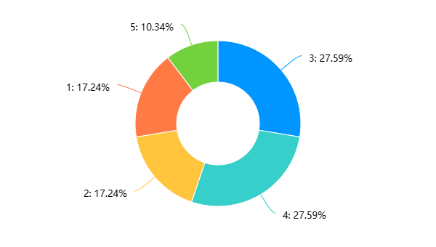Note :

1 : Less than 1 hour a day

2 : 1-2 hours per day

3 : 2-3 hours a day.

4 : 3-4 hours a day.

5 : More than 4 hours a day

**Figure 3.2.1.1**

* **College students' favorite type of short video**

It can be seen from the data in the figure 3.2.1.2 that learning video is the most popular viewing option, accounting for 44.83 %. This shows that college students are more inclined to acquire knowledge and skills when using video platforms, rather than just entertainment. Life records have also received some attention, accounting for 34.48 %, which shows that college students have a strong demand for sharing life and exchanging experience. In addition, the proportion of other videos is 20.69 %, which may include some entertainment, music, film and other content. In general, the demand for video platforms for college students is more diversified, not only limited to entertainment and recreation, but also includes acquiring knowledge and skills, sharing life and exchanging experience.

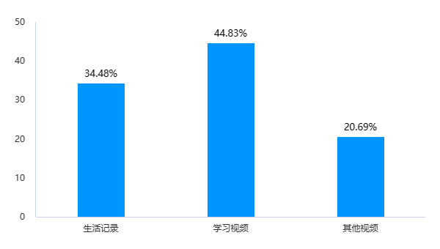

**Figure 3.2.1.2**

* **The most commonly used short video platform**

According to the data in the figure 3.2.1.3, TikTok is the most commonly used short video platform for college students, with a proportion of 44.83 %, micro-vision and Kuaishou are 34.48 % and 20.69 % respectively. The popularity of tremolo among college students may be due to its more diverse and interesting content, while the user interface is more friendly and easy to use. As a product of Tencent, micro-vision also has a certain user base among college students, but its content and user interaction may be relatively simple. The Kuaishou pays more attention to localization and regional characteristics, but it may have a relatively small audience among college students.

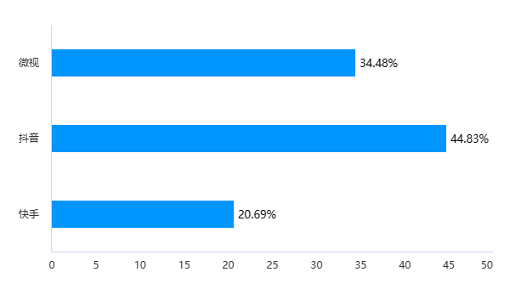

**Figure 3.2.1.3**

* **Analysis of sharing short video**

According to the data in the figure 3.2.1.4, most college students share a high proportion of short videos on social media, and the highest proportion is the choice of ' 3 : somewhat agree ', accounting for 31.03 %. This may be because short video is simple, vivid and easy to spread, which can attract the attention of young people and transmit information quickly. In addition, the proportion of choosing ' 2 : disagree ' and ' 1 : completely disagree ' is low, probably because now short video has become a popular form of social media, and most people will watch and share short video on social media.

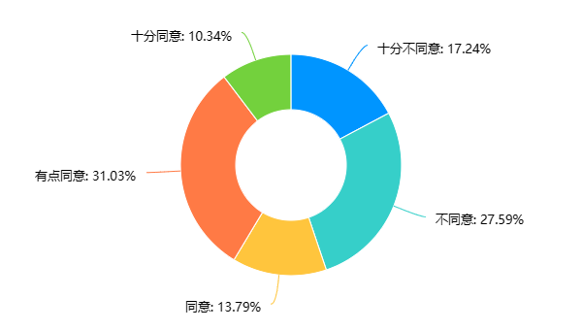

**Figure 3.2.1.4: results of the ‘often share short videos on social media’**

**3.2.2 Analysis of college students' cognition of short video**

College students' cognition of short video shows a more diversified distribution, but most people think that short video has a certain impact on themselves, which can help understand culture and trends, and can also relieve stress and fatigue. However, a small number of people think that short video has little or no effect on themselves.

* **The impact of short video on self**

According to the data in the figure 3.2.2.1, the influence of college students ' short video on themselves shows a relatively average distribution. Among them, 41.38 % of the respondents agree or agree with this statement, which may be because the short video content is vivid, interesting and diverse, which can arouse their interest and resonance, thus affecting their ideas and values. At the same time, 34.48 % of respondents believe that short video has little or no impact on themselves. This may be because they have a more objective attitude towards short video, can better distinguish between facts and false information, and will not be easily affected by short video.

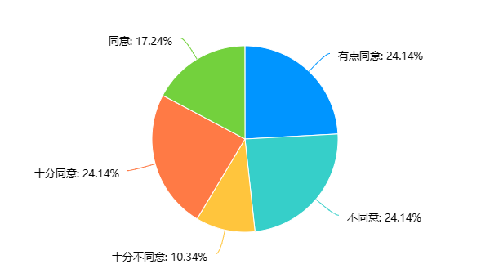

**Figure 3.2.2.1: results of the ‘Short video has a greater impact on yourself’**

* **Short video to understand culture**

According to the data in the figure 3.2.2.2, 51.73 % of college students believe that short videos can help them understand culture and trends. This may be because short videos cover a variety of topics, including culture, art, fashion, science and technology, etc. By watching short videos, they can access knowledge and trends in different fields. In addition, 24.14 % of college students chose to agree very much, indicating that they believe that short video can indeed provide this help, while only 6.9 % of college students completely disagree. This may be because they believe that the content of short video is not deep enough, only superficial understanding, can not really understand the culture and trends. Overall, it shows that most college students think that short videos can help understand culture and trends.

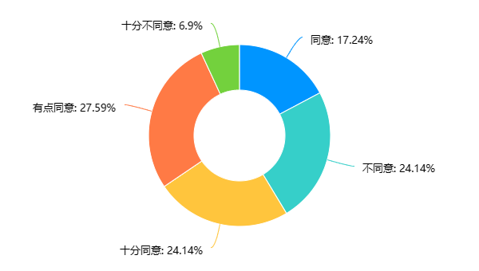

**Figure 3.2.2.2: result of the ‘Short videos can help understand culture and trends’**

* **Relieve stress and fatigue**

According to the data in the figure 3.2.2.3, it can be seen that most people ( 48.28 % ) think that short videos can relieve stress and fatigue, of which 27.59 % say they agree very much and 20.69 % agree. In addition, 20.69 % of people think a little agree, 13.79 % of people think disagree, 4.17 % of people think completely disagree. This shows that short videos can help people relieve stress and fatigue to some extent, but not everyone thinks so. Maybe some people think that short video is just a way of entertainment, which is not significant for relieving stress and fatigue.

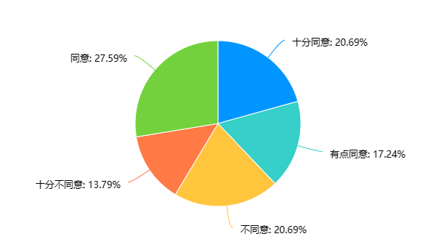

**Figure 3.2.2.3: result of the ‘Short video can relieve stress and fatigue’**

**3.2.3 Interview analysis**

It can be seen from the answers of the three interviewers that there are differences in their cognition and use of short videos. Among them, the first interviewer believes that there is a certain relationship between the frequency and performance of short videos, but moderate viewing can relieve learning pressure ; the second interviewer believes that short videos are mainly for entertainment, but they can also be used as learning aids ; the third interviewer believes that short video can be used as a learning aid, but excessive addiction will affect learning efficiency.

In the choice of short video platform, the three interviewers have their own preferences. The first interviewer prefers to watch short videos on Douyin, the second interviewer prefers to watch on the Kuaishou, and the third interviewer has no clear preference.

In terms of the originality of short video content, all three interviewers think it is very important. The original short video content can attract the attention and interest of the audience, and also bring more attention and fans to the video author.

For the future development trend of short video, all three interviewers believe that short video will be more intelligent, personalized and social. For example, artificial intelligence technology can help the video production process more efficient and time-saving ; the intelligent recommendation system can provide users with more accurate short video content recommendations based on their preferences and historical browsing records. At the same time, short videos will also focus more on social interaction, further enhancing the user experience and platform stickiness by strengthening the connection and interaction between users.

On the whole, short video has become one of the main ways for people to entertain, and it can also be used as a learning aid. In the future, with the continuous development of technology, short videos will be more diversified and intelligent, providing users with a better viewing experience.

**Appendix 1:**

Interviewer 1:

1. 我认为短视频的频次和成绩有一定的关系。如果一个人经常沉迷于短视频，忽略了学习和工作，那么他的成绩肯定会受到影响。但是如果能够合理地利用短视频，适度观看，不会对成绩产生太大的影响。

2. 我认为使用短视频主要是为了娱乐。虽然短视频也可以作为学习辅助，但是大多数人使用短视频还是为了消遣和娱乐，而不是为了学习。

3. 我更喜欢在抖音上看短视频。因为抖音的内容更加丰富多样，涵盖了各个领域，而且短视频的制作质量也比较高，能够吸引我的注意力。

4. 我认为短视频内容的原创性很重要。如果一个短视频只是简单地复制其他人的内容，那么它就失去了吸引观众的价值。原创内容能够展现制作者的独特思想和创意，更容易吸引观众。

5. 我认为短视频的未来是非常光明的。随着人们对短视频的需求越来越高，短视频的市场份额也会越来越大。未来，短视频将会成为人们消遣娱乐的主要方式，也将成为商业营销的重要手段。

Interviewer 2 ：

1. 我认为观看短视频的频次和成绩之间存在一定的关系。过度沉迷于观看短视频可能会分散学习时间和注意力，从而影响成绩。但是，适度观看短视频可以缓解学习压力，提高学习效率。

2. 在我看来，使用短视频主要是为了娱乐。虽然短视频可以作为学习辅助，但是其娱乐性更强，更容易吸引人们的注意力。

3. 我更喜欢在抖音上看短视频。因为抖音的内容更加多样化，有趣的短视频比较多，而且可以根据自己的兴趣爱好进行推荐。

4. 我认为短视频内容的原创性很重要。原创的短视频可以体现出作者的才华和创造力，更容易吸引观众的注意力和认可。

5. 短视频的未来是非常广阔的。随着技术的不断发展，短视频的制作和传播方式也会越来越多样化。未来的短视频可能会更加个性化和交互化，更好地满足人们的需求和兴趣。

Interviewer 3：

1. 我认为观看短视频的频次和成绩之间确实存在一定程度的关系。因为频繁地看短视频可能会导致学习效率下降，时间浪费。同时，如果对于某些科目或知识点，只是想着通过短视频搞定，那么很容易停留在表面，无法深入理解和掌握。

2. 短视频既可以作为娱乐工具，也可以用来辅助学习。尤其对于一些生动形象的教学内容，短视频可以通过图文并茂的方式讲解知识，并带有生动的画面和声音，使学习过程更加轻松愉快，易于记忆和理解。

3. 我更喜欢在快手上看短视频。原因是快手上的短视频内容比较丰富，涵盖面广，而且用户本身有很强的互动性，可以进行评论、点赞等互动操作。同时，快手的用户评分制度相对较为完善，可以有效筛选出优质的短视频内容。

4. 短视频内容的原创性很重要。原创性的短视频内容可以提供新鲜的视角和独特的创意，更加能够吸引用户的注意力和兴趣。此外，原创性内容也可以为视频作者带来更多的关注度和粉丝，有助于提升其声誉和影响力。

5. 短视频未来的发展趋势将会越来越多地涉及到智能化、个性化和社交化方面。例如，人工智能技术可以帮助视频制作过程变得更加高效、省时省力；智能推荐系统可以根据用户的喜好和历史浏览记录为其提供更准确的短视频内容推荐。同时，短视频也会更加侧重于社交互动，通过强化用户之间的联系和互动，进一步提升用户体验和平台的粘性。